**🚗 Accident Analysis Dashboard (Excel Project)**

**📌 Project Overview**

This project focuses on analyzing accident data using **Microsoft Excel** to uncover trends, causes, and patterns that can help improve road safety. The interactive dashboard provides actionable insights into accident hotspots, vehicle involvement, and time-based accident patterns.

**❓ Problem Statement**

Road accidents are a critical issue, leading to loss of lives, injuries, and property damage. Policymakers and traffic authorities often face challenges in:

* Identifying **accident-prone areas**
* Understanding the **causes of accidents**
* Analyzing **time-based patterns** (day, month, season)
* Determining the **impact of vehicle type and road conditions**

Without data-driven insights, it becomes difficult to design effective road safety measures.

**🛠 Approach to Solve**

1. **Data Collection:** Accident dataset prepared and imported into Excel.
2. **Data Cleaning & Transformation:** Ensured consistency, removed errors, and formatted the dataset for analysis.
3. **Exploratory Data Analysis (EDA):** Identified accident trends using pivot tables, charts, and Excel functions.
4. **Dashboard Creation:** Designed an **interactive dashboard** using slicers, conditional formatting, and charts for clear visualization.
5. **Insights Generation:** Extracted key findings to support decision-making.

**🧹 Data Cleaning & Understanding**

The dataset underwent the following steps:

* **Handling Missing Values:** Removed or imputed missing accident details.
* **Standardization:** Unified formats for dates, vehicle types, and locations.
* **Error Checking:** Corrected duplicate entries and inconsistencies in accident categories.
* **Derived Columns:** Created calculated fields (e.g., accident severity category, time-of-day groupings).
* **Exploration:** Checked distributions and frequency of accidents by year, month, and vehicle type.

**📊 Dashboard Features**

* **Accidents by Year & Month** (trend analysis)
* **Accidents by Location** (hotspot detection)
* **Accidents by Vehicle Type** (car, bus, two-wheeler, etc.)
* **Accident Severity** (minor, major, fatal)
* **Interactive Filters:** Users can filter data by year, location, and severity for deeper analysis.

**🔑 Key Insights**

* Identified **peak accident times** and months.
* Highlighted **most affected vehicle categories**.
* Found **high-risk accident zones** requiring immediate policy attention.
* Showed **severity patterns** across different conditions.

**📂 Files in Repository**

* Accident Analysis Dashboard.xlsx → Main Excel dashboard with cleaned data and visualizations.
* README.md → Project documentation.

**🚀 How to Use**

1. Download the Excel file from this repository.
2. Open in **Microsoft Excel (2016 or later)**.
3. Use the dashboard slicers and charts to explore accident data interactively.

**📌 Tools Used**

* **Microsoft Excel**
  + Pivot Tables
  + Charts & Graphs
  + Conditional Formatting
  + Slicers & Filters

# **Road Accident Dashboard (Excel-Based)**

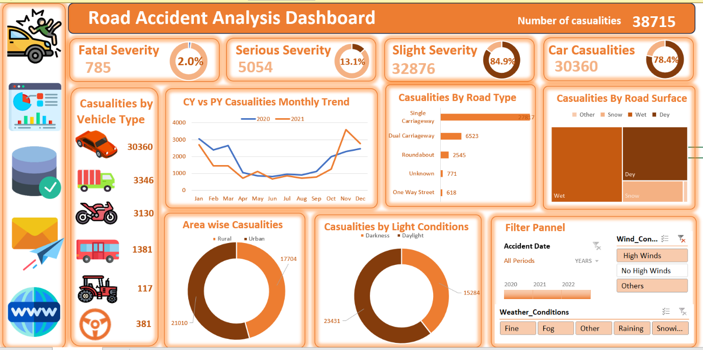

## Purpose of the Dashboard

This dashboard is created to **analyze and visualize road accident data** across different factors such as accident severity, vehicle type, road type, lighting condition, and area type (urban/rural). It helps in identifying patterns and supporting data-driven decision-making for road safety initiatives.

## Step-by-Step Structure to Build the Dashboard

### **PART 1: Primary KPIs Section**

**What we are making:**

Visual blocks with key performance indicators (KPIs) to give a quick summary.

**🔧 KPIs to Create:**

1. **Total Casualties**
2. **Fatal Casualties (Severe Deaths)**
3. **Serious Casualties (Critical Injuries)**
4. **Slight Casualties (Minor Injuries)**
5. **Casualties by Cars**

**Visualizations:**

* Use **number cards** (big bold values)
* Add **donut charts** (Data Labels ON, No Legends, % formatting)
* Insert **icons or shapes** to visually represent each KPI

### **PART 2: Secondary KPIs – Casualties by Vehicle Type**

**What we are making:**

A summary of casualties grouped by type of vehicle.

**🔧 Vehicle Groups:**

* Cars
* Motorcycles
* Buses
* Trucks
* Tractors
* Others

**Visualizations:**

* Use **icon + label** combinations (SmartArt or manual shapes)
* Add small **number cards** below or beside each icon
* Use **shapes or images** of vehicle types from Excel Icons or Insert → Pictures

### **PART 3: CY vs PY Casualty Trend (Monthly)**

**What we are making:**

A line chart comparing current year (CY) vs previous year (PY) month-wise data.

**Visualizations:**

* Use **Line Chart**
* X-axis: Month names (Jan to Dec)
* Y-axis: Casualty numbers
* Use two series: one for 2021, one for 2022
* Add **Data Labels and Legend**

### **PART 4: Casualties by Road Type**

**What we are making:**

Compare accident counts across different road types.

**Visualizations:**

* Use **Horizontal Bar Chart**
* Categories: Single carriageway, Dual carriageway, Roundabout, One-way, Slip road, etc.
* Sort by descending order

### **PART 5: Casualties by Road Surface Condition**

**What we are making:**

Show how many casualties occurred on dry, wet, or snow-covered roads.

**Visualizations:**

* Use **Tree Map** or **100% Stacked Bar**
* Categories: Dry, Wet, Snow/Ice

### **PART 6: Urban vs Rural Casualties**

**What we are making:**

Compare how many accidents happened in Urban vs Rural areas.

**Visualizations:**

* Use **Donut Chart**
* Two categories: Urban, Rural
* Highlight with contrasting colors (e.g., brown vs light beige)

### **PART 7: Light Condition Analysis (Day vs Night)**

**What we are making:**

Determine when most accidents happen — during daylight or darkness.

**Visualizations:**

* Use **Donut Chart**
* Categories: Daylight, Darkness
* Show both count and percentage

### **PART 8: Filter Panel**

**What we are making:**

Interactive panel to filter data based on:

1. **Urban or Rural**
2. **Years (2021, 2022, 2023)**
3. **Day of Week (Mon–Sun)**

**Visualizations:**

* Use **Slicers** (Insert > Slicer from Pivot Table)
* Style them with custom colors matching your theme

### **PART 9: Linked Image Navigation**

**What we are making:**

Clickable icons that navigate to the dataset or pivot pages.

**How to do it:**

1. Insert image or icon (Insert > Icons or Pictures)
2. Right-click > Link > Place in this Document > Select Sheet (e.g., Dataset)
3. Add a small hover effect using formatting

### **Data Setup Recommendation**

* Use **Pivot Tables** behind all visuals
* Store raw data in one clean sheet (RoadAccidentData)
* Name your ranges or use Excel Tables
* Use helper columns (e.g., Year, Month, Light, Road Type Group) for better analysis

### **Tools & Features Used**

|  |  |
| --- | --- |
| Feature | Use Case |
| Pivot Tables | Aggregating accident data |
| Pivot Charts | Creating dynamic visuals |
| Donut Charts | For % comparison |
| Line Charts | Time-series (month) analysis |
| Bar Charts | Category-wise comparisons |
| Slicers | Interactive filtering |
| Shapes/Icons | Visual storytelling & linking |
| Conditional Formatting | For color indicators |